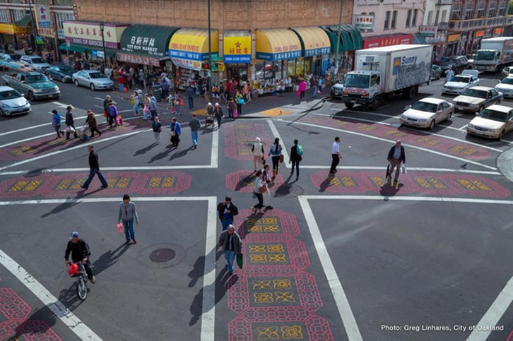
Dear UCI,
I almost died today.
Not because of the stress from my classes, or my horrible sleep schedule, but because of the poorly designed stoplight on California Avenue in front of AV housing. I cross that intersection every day, whether to go to the M-line bus stop or to start my runs. But today, I almost lost my life to a car that didn’t yield for me — granted I was wearing all black and running at night.
It’s not my fault — pedestrian’s right of way, right? But I can’t blame the car either. I sympathize with them when I see an endless stream of students cross that “stoplight” and seemingly wait for hours.
This design flaw had me spiraling down a rabbit hole, sparking an interest in urban planning. I went back home during Spring break to Oakland, Calif where a gorgeous intersection located in Chinatown made me think of how ours could be improved.
A crosswalk in McLean, Va., a suburb of Washington, D.C. leads a blogger to question, “Is this the most useless crosswalk ever?” “It appears to serve as a connection between nothing, and is an example of "bad pedestrian design of the worst sort,” writes Michael Rodriguez. Planners need to be wary of these types of crosswalks because they communicate that planners don't care about pedestrians, potentially implementing “token” crosswalks that don't do any good for pedestrian infrastructure. “It speaks to horrible planning, bad design and is an overall insult to pedestrian infrastructure,” Rodriguez adds.
An article from WIRED on pedestrian infrastructure provided some interesting research.
One of the studies explores how pedestrian death statistics “have jumped by more than 50 percent in the past decade, to more than 6,000 in 2018,”Vock explains. This is due to multiple factors that aren’t related to just design. Experts have blamed the influx on factors including the proliferation of smartphones that distract both drivers and pedestrians, the rising popularity of big SUVs and road design that encourages speeding. That’s one reason pedestrian infrastructure has entered the spotlight.
Another reason for the confusion is that few studies have analyzed how drivers react to novel crosswalk designs; some of which have led to inconclusive results. Oklahoma transportation engineers, for example, studied the effects of a crosswalk painted to appear 3D for safety precautions at a crossing near a school. This gave drivers the illusion that the stripes were raised blocks. The engineers found that at first, many motorists slowed down when they saw the markings. But they also found that a significant number of motorists swerved to avoid them, replacing one dangerous behavior with another. “Additional study is needed to determine if installing a 3D crosswalk diminishes or enhances pedestrian safety,” the researchers concluded in 2018.
I saw this other crosswalk, not too far away from UCI that had a major flaw as well. There was a massive barrier separating the roads that created an impossible obstacle for people in wheelchairs.
In a society that increasingly emphasizes inclusivity and accessibility, it’s disheartening to witness such oversights in urban planning. The purpose of a crosswalk is to provide a safe passage for pedestrians to cross busy roads. However, when basic accessibility needs are disregarded, it turns into a walkway to nowhere.
This seemingly minor design flaw can have significant consequences for people with disabilities. It sends a message that their needs were overlooked or deemed less important.
As designers, urban planners, and citizens, it’s essential to prioritize inclusivity in our infrastructure. By considering accessibility from the outset, we can create environments that empower all members of our community to move freely and independently.
My near-miss experience at the poorly designed stoplight near AV housing has made me think about the critical need for improved pedestrian safety measures in our urban environments.
Brian Ngo is an Opinion Intern for the spring 2024 quarter. He can be reached at bpngo2@uci.edu

